RR ITEC
RR ITEC Tableau Classroom Notes
By Ram Reddy

Contents
1. Tableau 4
1.1 Introduction 5
1.2 Installation of tableau desktop 7
1.3 Datasource Connections 8
1.4 Data Types and Field Types 12
1.4.1 Data Types 12
1.4.2 Field Types 13
1.5 Around Desktop Work Area 14
1.6 Develop Visualization using super store data 15
1.7 Develop Filters 16
1.7.1 Basic Filters 16
1.7.2 Quick Filters 17
1.7.3 Context Filters 18
1.8 Joins 20
1.9 Data Blending 25
1.10 Union 28
1.11 Custom Sql Query 29
1.12 Sets 30
1.13 Bins 35
1.14 Groups 36
1.15 Hierarchies 37
1.16 Calculations 39
1.17 Organizing Fields using Folders 44
1.18 Parameters 45
1.19 Conditional formatting 49
1.20 Highlighters 50
1.21 Types of Charts 51
1.22 Dashboard 57
1.23 Story 65
1.24 Creating Tableau Online Login and Tableau Site 67
1.25 Create Project in online/cloud 70
1.26 Publish Workbook to Online 71
1.27 Publish Datasource to online 72
1.28 Develop a work book using web datasource 73
1.29 Installing Tableau Server 74
1.30 Create Tableau Site in the server 75
1.31 Create Tableau Project In the server in the site 76
1.32 Publish Workbook to server 77
1.33 Publish Datasource to server 78
1.34 Development directly in tableau server 79
1.35 Create users 81
1.36 Create Group 84
1.37 Map Users to group 85
1.38 About Roles and permission rules 86
1.39 Data Security 88
1.40 Scheduling and subscriptions 91
1.41 Command Line Utilities 95
1.41.1 Tabcmd 95
1.41.2 Tabadmin 96
1.42 Revision History 98
1.43 List of Tableau Processes 100
1.44 Working with Log Files 102
1.45 Viewing Underlying SQL Queries 103
1.46 Performance tuning 104
1.47 Deployment 109

Tableau

Introduction
- Tableau can help anyone see and understand their data. Connect to almost any database, drag and drop to create visualizations, and share with a click.
- VizQL is a visual query language that translates drag-and-drop actions into data queries and then expresses that data visually. VizQL delivers dramatic gains in people's ability to see and understand data by abstracting the underlying complexities of query and analysis.
- VizQL is patent language by tableau corporation
- Tableau components/ecosystem
  - Tableau Desktop
Tableau Desktop is used to visualize and analyze data, create workbooks, visualizations/sheet, dashboards and stories. Tableau Desktop can then publish these to Tableau Server/Tableau Online
  - Tableau Server(Own Home)(Big Company)
Tableau Server, is an online solution for sharing/distributing and collaborating on content created in Tableau.
Shareable. Create workbooks and views, dashboards and data sources in Tableau Desktop, and then publish this content to the server.
Secure. Manage access to published content to help protect sensitive data. Administrators can set user permissions on projects, workbooks, views, and data sources.
Mobile. See and interact with the most up-to-date server content from anywhere, in a browser or the Tableau Mobile app.
  - Tableau Online(Rent Home)(Small Company)
Tableau Online is your analytics platform fully hosted in the cloud. Publish dashboards and share your discoveries with anyone. Invite colleagues or customers to explore hidden opportunities with interactive visualizations and accurate data. All easily accessible from a browser or on the go with our mobile apps.
  - Tableau Public
Tableau Public is free software that can allow anyone to connect to a spreadsheet or file and create interactive data visualizations for the web
  - Tableau Reader
Tableau Reader is a free desktop application that you can use to open and interact with data visualizations built in Tableau Desktop. Filter, drill down and discover.
  - Tableau Mobile
Tableau Mobile is the fastest, most delightful way to stay on top of your data on your tablet or phone
  - Vizable
Vizable is a free ios app that turns your data into beautiful, interactive graphs.
If you have a tablet, data, and questions, Vizable is for you

Installation of tableau desktop
- Download 14 days license software from http://www.tableau.com/esdalt
- One year license for students https://www.tableau.com/academic/students
- Refer tableau-public-desktop-installation from rritec website

Datasource Connections
- These are two types
  - Live Connection
  - Extract connections
    - Extract Some data
    - Extract all data
Connections
Live
Extract
Extract All Data
Extract Some Data
Handson 1: Develop a report using oracle Live connections
    - Create a table in oracle
    - Connect to the oracle database
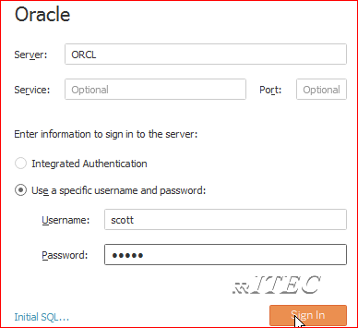
    - Drag and drop a table (example test1) and select connection type as live
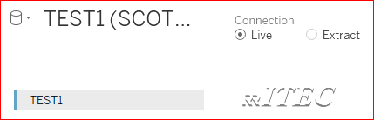
    - Click on sheet1 and observe output
    - Go to database and add 1 record to test1 table and refresh data source ,we can see new record.
Handson 2: Develop a report using oracle extract connections
- Do similar to above by selecting extract option
Handson 3: Refreshing Extract connections
- Right Click on datasource → Extract → refresh
Handson 4: Converting Live to Extract
- Open live connection and right click on datasource → extract data
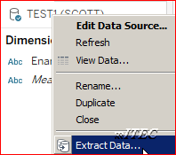
Handson 5: Converting Extract to Live
- Uncheck use extract data option

Handson 6: About TDE
- http://www.tableau.com/about/blog/2014/7/understanding-tableau-data-extracts-part1
- https://www.tableau.com/about/blog/2014/7/why-use-tableau-data-extracts-32187
- https://www.tableau.com/tableau-data-extracts-part3
Exercise 1: Do above Handsons 1 to 5 using excel ,csv files and fixed files.
Hint: create sample file or get from labdata and develop reports
Exercise 2: Develop a report by connecting to MS Access database.
Hint: Connect to access → go to lab data and get scott data file and develop the report
Exercise 3: Develop a report by connecting to google analytics.
Hint: Connect google analytics add dimension city and measure new users and observe report
Exercise 4: Develop a report by connecting to google sheet.

Data Types and Field Types

Data Types
- All fields in a data source have a data type. The data type reflects the kind of information stored in that field, for example integers (410), dates (1/23/2015) and strings (“Wisconsin”).
- The data type of a field is identified in the Data pane by one of the icons shown below.
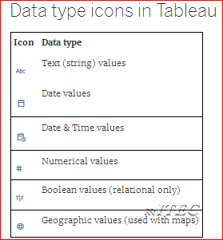
- You can change the data type for a field either on the Data Source page or in the Data pane.
1 .Datasource window
- 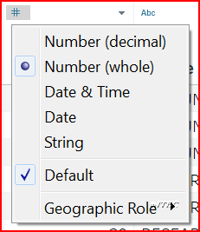
2 Sheet Window
- 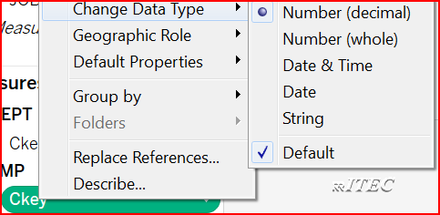

Field Types
- When you connect to a new data source, Tableau assigns each field in the data source to either the Dimensions area or the Measures area of the Data pane, depending on the type of data the field contains.
- If a field contains categorical data (such as names, dates, or geographical data), Tableau assigns it to the Dimensions area.
- If a field contains numbers, Tableau assigns it to the Measures section
- If you are dragging a field from the Dimensions area, the resulting field in the view will be discrete (with a blue background). If you are dragging a field from the Measures area, the resulting field will be continuous (with a green background)
- By default, dimensions are discrete and measures are continuous, but in fact all four combinations are possible
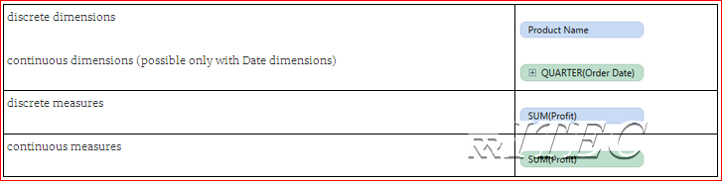
- We can convert some of the measures into dimensions (example empno, student number ..etc)

Around Desktop Work Area
- Work Book
  - Data Source Section
  - Work Book Section
    - Data Section
      - Dimensions
      - Measures
      - Sets
      - Parameters
    - Tableau Work Area Section
      - Shelf Cards (row/column/pages/filters)
      - Marks Cards(color/size/label/detail/tooltip..etc)
      - Sheet
      - Dashboard
      - Story
      - ShowMe

Develop Visualization using super store data
- To explain tableau capabilities, tableau gave one excel data and it is came as part of the installation.
- It is available in location \Documents\My Tableau Repository\Datasources\10.2\en_US-US\Sample – Superstore.xls
- This excel has three sheets (orders, returns and people) and tableau will treat each sheet as one table
- Open Tableau → Click on connect to Excel → Navigate to RRITEC labdata folder → Select sample – superstore.xls excel file
- Drag and drop orders,returns and people
- Click on sheet1 → double click on category and sales
- Observe output

Develop Filters
- Filtering is the process of removing certain values or range of values from a result set.
- It is equal to SQL where and having clauses
- Tableau filtering feature allows both simple scenarios using field values and advanced calculation / context based filters.

Basic Filters
- There are three types of basic filters available in Tableau
  - Filter Dimensions: →The filters applied on the dimension fields.
  - Filter Measures: → The filters applied on the measure fields.
  - Filter Dates: → The filters applied on the date fields.
Hands-on 1: Develop a report by applying filter on dimensions Field
Scenario: Show employee info if employee count in department is more than 4
- Connect to scott_excel → drag and drop emp and dept
- Click on sheet1 → Double click on empno,ename,job,dname and sal
- Drag and drop dname into filter shelf → click on condition tab → select by field → select empno → select count → select operator as > and value as 4 → click on ok
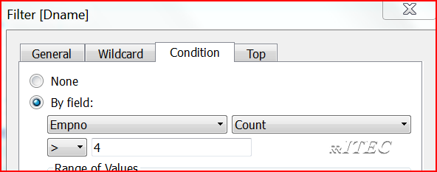
- Observe and understand result
Hands-on 2: Develop a report by applying filter on measures
Scenario: Show employee info if employee salary is more than 2000
- In above work book click on new sheet → double click on empno,ename,job,sal
- Drag and drop sal into filter shelf
- Click on next → select at least → type 2000 → click on ok
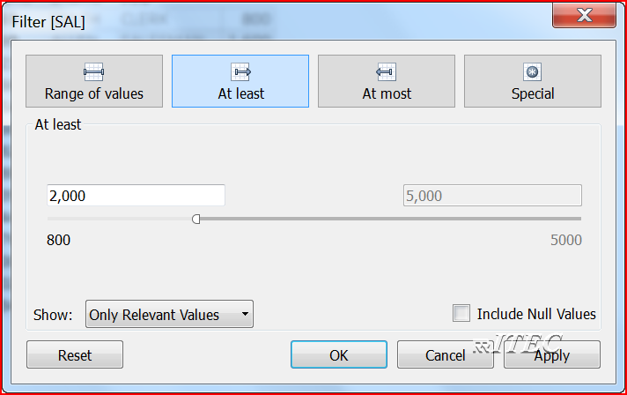
Hands-on 3: Develop a report by applying filter on dates
Scenario: Show employee info if employee hire date is greater than 01-jan-1982
- In above work book click on new sheet → double click on empno,ename,job,hiredate,sal
- In rows shelf → click on hiredate down arrow → select attribute
- Drag and drop hiredate into filter shelf
- Click on next → select range of dates → select dates as shown below → click on ok
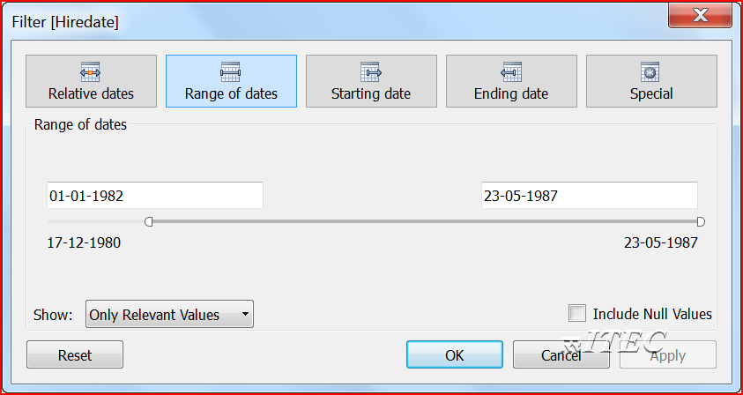

Quick Filters
- Many filter types in Tableau are quickly available using right-click option on the dimension or measure
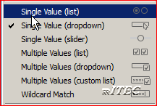
- Drag and drop any dimension into columns and measure into rows
- Press ctrl and drag and drop dimension into filter shelf
- Right click on dimension in filter shelf → click on show filter
- Click on show filter down arrow → observe all the option and play around it.

Context Filters
- By default, all filters that you set in Tableau are computed independently. That is, each filter accesses all rows in your data source without regard to other filters. However, you can set one or more categorical filters as context filters for the view. You can think of a context filter as being an independent filter. Any other filters that you set are defined as dependent filters because they process only the data that passes through the context filter.
- You may create a context filter to:
  - Improve performance – If you set a lot of filters or have a large data source, the queries can be slow. You can set one or more context filters to improve performance.
  - Create a dependent numerical or top N filter – You can set a context filter to include only the data of interest, and then set a numerical or a top N filter.
Hands-on 1: Create Context Filters
Scenario: Get top 2 sales sub categories within the furniture category.
This example walks you through how to create a context filter. First you’ll filter a view to show the top 2 products by sales. Then you’ll create a context filter on product category so you can see the top 2 furniture category products.
- Use the Sample - Superstore data source to create the initial view shown below.
- Drag and drop sub category in rows and sales in columns
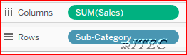
- Sort Sales in descending order and understand data
- Press ctrl and drag and drop sub category in filter shelf → click on → select as shown
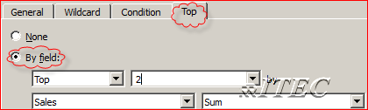
- Drag and drop category in filter shelf → select furniture
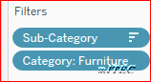
- Right click on category → select add to context → observe output and understand data
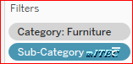
Exercise: Develop a report to get top 2 salaried employees in sales department.

Joins
A relationship is called as join. In database we have mainly 5 joins.
  - Equi join / Normal Join / Inner Join
  - Outer join (Left, Right, Full)
  - Non Equi join
  - Self-join
  - Cross join
/* ********Get Dname, Ename, Sal****01 Equi Join ******/
Select Ename, sal, dname From EMP, dept Where emp.deptno=dept.deptno

/* ********Get Grade, Ename, Sal****02 Non Equi Join ******/
Select Ename, sal, Grade from EMP, salgrade Where sal>=losal and sal <=hisal

/* ********Get DNAME, COUNT_OF_EMPLOYEES****03 outer Join ***/
Select dname, count (empno) as COUNT_OF_EMPLOYEES From emp, dept Where emp.deptno (+)=dept.deptno group by dname

/* ********Get Employee_name, Mangaer_name****04 Self Join ***/
Select e.ename as Employee_name, m.ename as Mangaer_name From emp e, emp m Where e.mgr=m.empno

/* ********Get Dname, Ename, Sal****05 Cross Join ******/
Select Ename, sal, dname from emp, dept
- Equi Join/Inner Join : Develop a report to get dname wise sal expenditure
  - Open Tableau → Click on connect to excel → navigate to RRITEC labdata folder → Select Scott Data excel file
  - Drag and drop EMP and DEPT → observe the join condition
  - Click on sheet1 → drag and drop dname into rows and sal into columns
  - Observe output
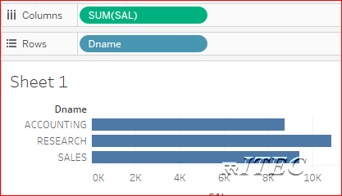
- Left Outer Join : Develop a report to get dname wise count of employees
  - Open Tableau → Click on connect to excel → navigate to RRITEC labdata folder → Select Scott Data excel file
  - Drag and drop DEPT and EMP→ observe the join condition→ select left outer join
  - Click on sheet1
  - Under data tab → Under EMP → Right click on empno → Click on convert dimension
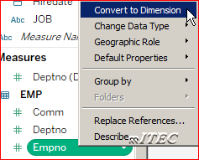
  - drag and drop dname into rows and empno into columns
  - In column shelf → Click on empno down arrow →Click on measure →count
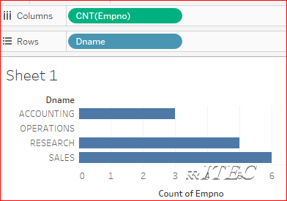
- Non Equi Join : Develop a report to get ename,sal,grade
  - Open Tableau → Click on connect to Access → navigate to RRITEC labdata folder → Select Scott Data access database
  - Drag and drop emp and salgrade → develop the join condition

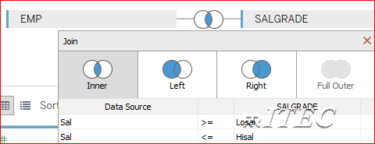
  - Click on sheet1 → Under the data tab → select grade column → convert to dimension
  - Drag and drop ename,grade and sal as shown below
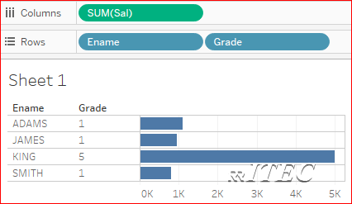
- Self Join : Get manager name and employee name
  - Open Tableau → Click on connect to excel → navigate to RRITEC labdata folder → Select Scott Data excel file
  - Drag and drop EMP→ rename as Employee Details
  - Again Drag and drop EMP→ rename as Manager Details
  - Provide below join Employee Details.mgr =Manager Details.empno
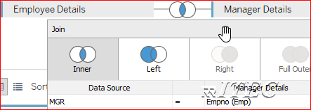
  - Click on sheet1
- Rename Ename column of Employee Details as Employee Name
- Rename Ename column of Manger Details as Manager Name
- Drag and drop both the columns into rows shelf and observe it
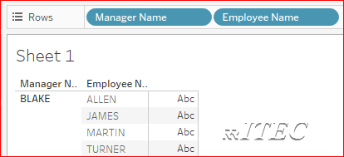
- Cross Join : Directly not supported ,however we can do below workaround
  - Create one common column in both the tables .to understand more please do below activity
  - Open Tableau → Click on connect to excel → navigate to RRITEC labdata folder → Select cross join excel file
  - Drag and drop emp and dept and notice that we created one common column cross join key with same data and join using this column
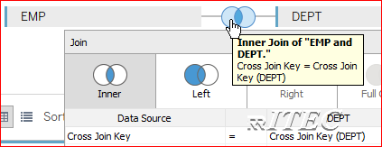
  - Click on Sheet1
  - Drag and drop Ename and Dname into rows shelf → observe Cartesian product result
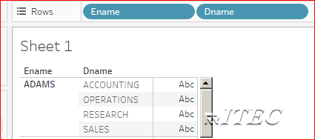
- Can we create above 5 joins using Access Datasource?
  - No (full outer join disabled )

Data Blending
- Join combines the data from multiple tables into single datasource .If we want to combine the data from multiple data source into single worksheet then we will use data blending
- To perform data blending at least we should have one common column and one common value.
- For example, suppose you have transactional data stored in Salesforce and quota data stored in an Excel workbook. The data you want to combine is stored in different databases, and the granularity of the data captured in each table is different in the two data sources, so data blending is the best way to combine this data.
- When you use data blending to combine data, a query is sent to the database for each data source that is used on the sheet. The results of the queries, combined by Tableau.
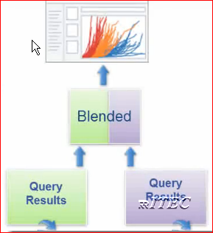
- Data blending performed in two ways
  - Automatic
  - Manual

- Data Blending Automatic : Data blending using excel and text file using one same column name
  - Open Tableau → Click on connect to excel → navigate to RRITEC labdata folder → Select products actual sales excel file
  - Go to data menu→ new data source → navigate to RRITEC labdata folder → Select products target sales text file
  - Click on sheet1
  - Drag and drop product from actual data source into rows
  - Actual sales and target sales onto text
  - Here actual sales is called as primary datasource and target sales is called secondary data source .
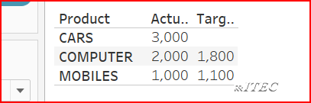
  - First used source treated as primary and it is identified using blue right mark.
- Data Blending Manual : Data blending using excel and text file using no common column name
  - Open Tableau → Click on connect to excel → navigate to RRITEC labdata folder → Select products actual sales excel file
  - Go to data menu→ new data source → navigate to RRITEC labdata folder → Select products target sales1 text file
  - Click on sheet1
  - Drag and drop product from actual data source into rows
  - Actual sales and target sales onto text
  - Here actual sales is called as primary datasource and target sales is called secondary data source.
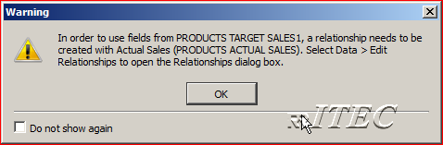
  - Go to data menu → Click on edit relationships → select custom → click on add → select product and product1 →click on ok → again ok
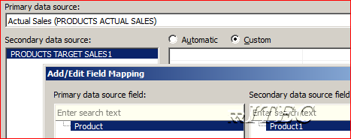
  - Observe output
  - Note: In data blending primary source will be left outer joined with secondary source. 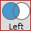

Union
- You can union your data to combine two or more tables from an Excel or Google Sheets workbook or text file data. The workbooks or text files must be in the same folder and come from the same connection.
- You union tables by appending values (rows) from one table to another.
- For best results, the tables that you combine must have the same structure. That is, each table must have the same number of fields, and related fields must have matching field names and data types.
Union excel data:
- Open Tableau → Click on connect to excel → navigate to RRITEC labdata folder → Select union data excel file
- Drag and drop New Union into work area
- Drag and drop all tables into union work area → click on ok
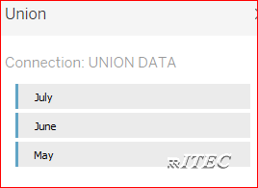
- Click on sheet1
- Convert day and purchase as dimensions
- Drag and drop day ,customer,purchase and type into rows shelf
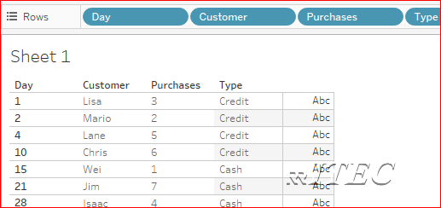

Custom Sql Query
- For most databases, you can connect to a specific query rather than the entire data set. Because databases have slightly different SQL syntax from each other, the custom SQL you might use to connect to one database might be different from the custom SQL you might use to connect to another. However, using custom SQL can be useful when you know exactly the information you need and understand how to write SQL queries.
- Though there are several common uses for custom SQL, you might use custom SQL to union your data across tables, recast fields to perform cross-database joins, restructure or reduce the size of your data for analysis, etc.
Union Oracle data:
- Create below two tables in scott schema
Create table emp1020 as Select deptno, sal from scott.emp where deptno in ( 10,20 );
Create table emp2030 as Select deptno, sal from scott.emp where deptno in ( 20,30 );
- Open Tableau → Click on connect to oracle → provide server :orcl Username: scott and Password: tiger → click on ok
- Drag and dropNew Custom Sql into work area
- Type below query in edit custom sql window → click on ok
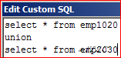
- Click on Sheet1 → convert deptno as dimension
- Drag and drop deptno and sal into rows shelf → observe output .

Sets
- Sets are custom fields that define a subset of data.
- These are two types
  - Constant set
  - Computed set/dynamic set
- Combining Sets : You can combine two sets to compare the members. When you combine sets you create a new set containing either the combination of all members, just the members that exist in both, or members that exist in one set but not the other. Combining sets allows you to answer complex questions to understand cohorts of data. For example, to determine the percentage of customers who purchased both last year and this year, you can combine two sets containing the customers from each year and return only the customers that exist in both sets. Another example would be to determine what products sell the most but also have the highest return rate.
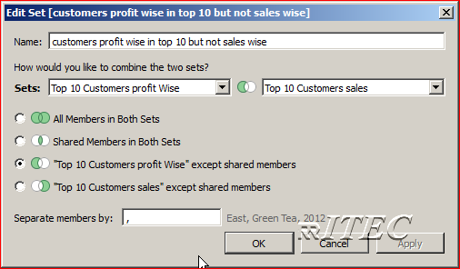
- Create a constant set : Top 10 Customers Sales Wise(today)
  - Open Tableau → Click on connect to excel → navigate to RRITEC labdata folder → Select Sample - Superstore excel file
  - Click on sheet1
  - Drag and drop customer name into rows ,sales into columns
  - Sort sales in descending order
  - Select top 10 customers manually → Click on create set
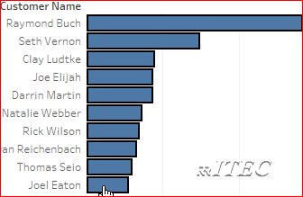
  - Provide name as Top 10 Customers sales → Click on ok
  - Remove customer name column from rows and drag and drop Top 10 Customers sales set into rows and observe output
    - If we create any set and if we drag it into the row shelf or column shelf, by default tableau will display IN/OUT mode where IN indicates members inside the set and OUT indicates members out of the set or condition
    - To display the values in the set, click on the set and show members in set (In sets, values are known as Members)
- Create a computed set : Top 10 Customers profit Wise
  - In above work book → under dimensions → right click on customer name → Click on create → set
  - Name it as Top 10 Customers profit Wise → Click on Top → by field →top →10 → profit → sum as shown below → click on ok
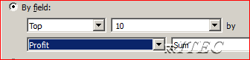
  - Click on Sheet 2 → develop report as shown below
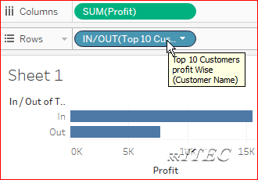
- Create combined set : Get customers profit wise in top 10 but not sales wise
  - In above work book → under sets → right click Top 10 Customers profit Wise → Click on create combined set → select as shown → ok
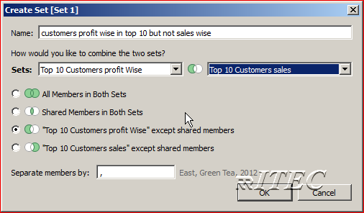
  - Develop report as shown
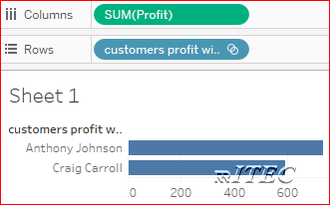
- Show Pie Chart for Employees as Top 5, Top 6-10 and Others
  - Open Tableau → Click on connect to excel → navigate to RRITEC labdata folder → Select Scott excel file
  - Click on sheet1
  - Right click on empno column →Click on Create → Set → Top → do as shown below → ok
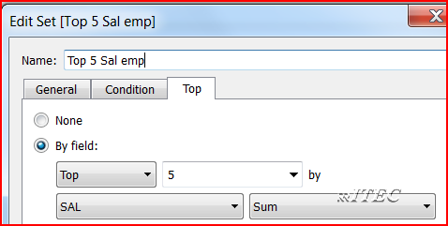
  - Right click on empno column →Click on Create → Set → Top → do as shown below → ok
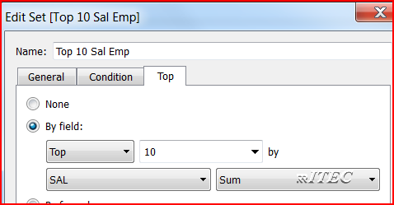
  - Select above twos sets → right click → click on create combined set → as shown below→ ok
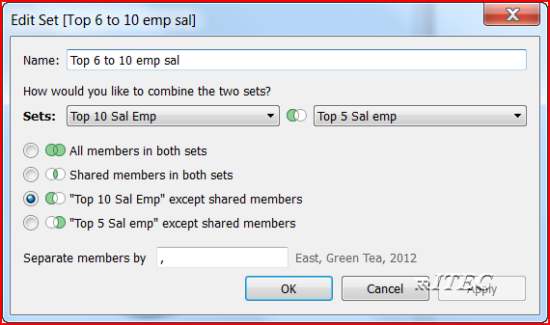
  - Create a calculation field as shown
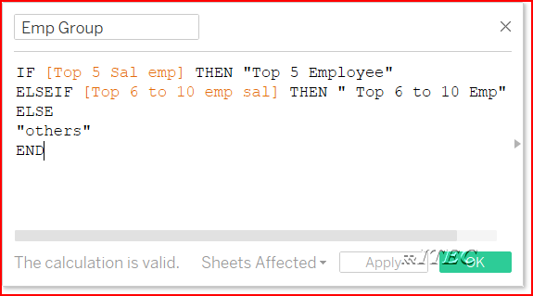
  - Drag Emp Group calculated column into Rows and sal into Columns.
  - You will See Bar Chart by Default. Now go to Show Me and select Pie Chart.
  - Drag and drop emp group and sal columns onto label

Bins
- On the measures, it is not possible to create Sets.
- If we want to perform similar kind of set analysis on measures, then we need to create bins.
- Bins is a container which holds the required values depending on the bin size.
- If we create a bin, tableau creates that field under dimension.
- Bins are used to identify the distribution of measure values.
- Find number of employee in each interval of 1000
  - Open Tableau → Click on connect to excel → navigate to RRITEC labdata folder → Select Scott Data excel file → drag and drop emp and dept
  - Click on sheet1
  - Right click on sal → create → Bins →Count_of_employees_in_1000_interval
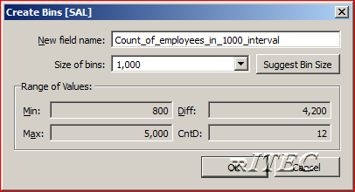
  - Click on ok
  - Drag and drop above bin and sal columns and change sal aggregation rule as count and observe output .
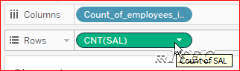

Groups
- A group is a combination of dimension members that make higher level categories.
- For example, if you are working with a view that shows average test scores by major/subject, you may want to group certain subjects together to create subject categories. English and History may be combined into a group called Liberal Arts while Biology and Physics may be grouped as Science subjects.
- Groups are also useful for both correcting data errors (e.g., combining CA, Calif., and California into one) as well as answering "what if" type questions (e.g., "What if we combined the East and West regions?).
- Find the total loss and profit using groups
- Open Tableau → Click on connect to excel → navigate to RRITEC labdata folder → Select Sample - Superstore excel file → drag and drop all tables
- Click on sheet1
- Right click on the profit → click on create → group → provide Field name : Loss_profit → select all the -ve vales → click on group→Name it as loss → select include others and name it as profit
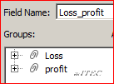
- Drag and drop loss_profit group and profit measure as shown and observe output
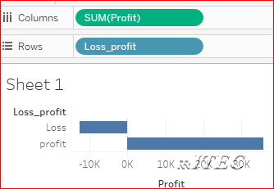

Hierarchies
- One to many relationship among columns is called as hierarchy
- Time hierarchies(in Tableau time hierarchy automatically created) .for example observe order date column
- Hierarchies are useful for
  - Drill down
  - Drill up
  - Drill across
- Drill down : Navigating from high level to low level is called as drilldown (ex : year → quarter→ month→ day)
- Drill up :Navigating from low level to high level is called as drill up (ex : Day → Month → Quarter → Year)
- Drill across: Navigating from one hierarchy to another hierarchy is called as drill across.(ex: Day → Country)
- Create geography hierarchy (country → State → city → Postal Code)
- Open Tableau → Click on connect to excel → navigate to RRITEC labdata folder → Select Sample - Superstore excel file → drag and drop all tables
- Click on sheet1
- Drag and drop state column on country and name it as geography hierarchy→ok
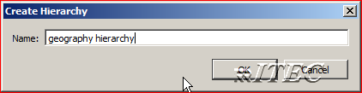
- Drag and drop city below state
- Drag and drop postal code below city
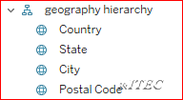
- Drag and drop geography hierarchy into columns and sales into rows observe output
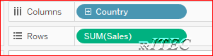

Calculations
- If your underlying data doesn't include all of the fields you need to answer your questions, you can create new fields in Tableau and then save them as part of the data source.
- For example, you could create a new calculated field called Profit that calculates the difference between the Sales and the Cost fields
- Calculated fields in tableau contain:
  - Functions
  - Fields
  - Parameters
  - Comments (Optional)
- We have different inbuilt functions in tableau
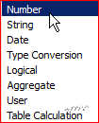
- Calculate totalsal and tax using emp data
- Open Tableau → Click on connect to excel → navigate to RRITEC labdata folder → Select Scott Data excel file → drag and drop emp ,dept table
- Click on sheet1
- Go to analysis menu → click on create calculation field
- Name it as totalsal and develop below expression .
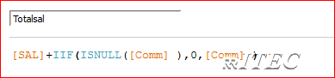
- Again Go to analysis menu → click on create calculation field
- Name it as tax and develop below expression .
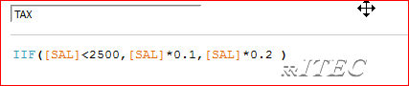
- Convert empno to dimensions
- Drag and drop empno,ename,job into rows shelf
- Drag and drop sal column into Text 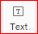
- Drag and drop comm onto sal column → organize comm after sal column
- Drag and drop totalsal and tax into measure values
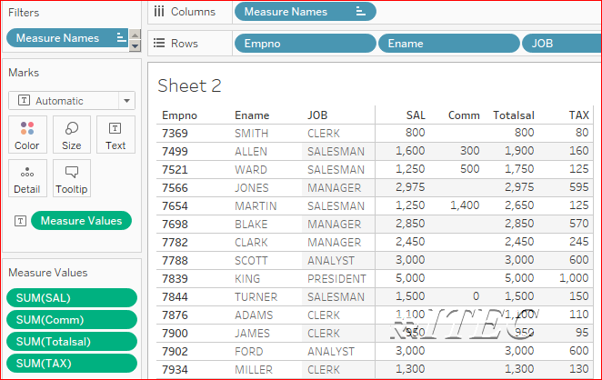
- Concatenation of dname and loc
- In above workbook click on Sheet2
- Go to analysis menu → click on create calculation field
- Name it as Dname - Loc and develop below expression .
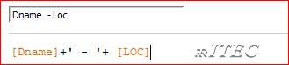
- Develop below report and observe it
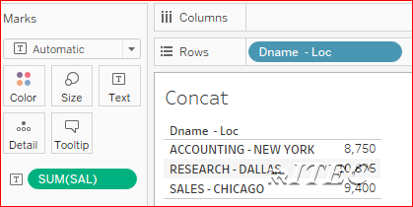
- Get Year part from the hiredate column
- In above workbook click on Sheet3
- Go to analysis menu → click on create calculation field
- Name it as year part and develop below expression .
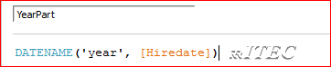
- Develop below report
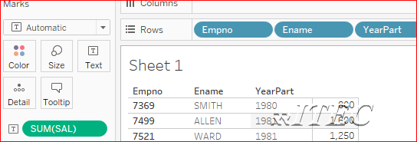
- Table Calculation
- A table calculation is a transformation you apply to the values of a single measure in your view, based on the dimensions in the level of detail.
- Drag and drop dname into rows and sal into text as shown
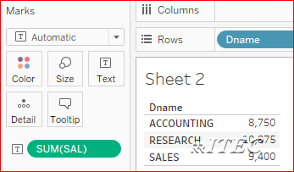
- Right click on sum(sal) → quick table Calculation →click on percent of total
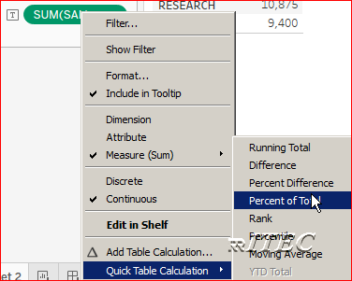
- Drag and drop sal column onto above percentage column
- Right click on second sum(sal) column → quick table Calculation →click on rank
- Select the rank column → right click → format → go to drop down of fields → select Rank of sum(sal) → select numbers drop down → number(custom) →select decimal places as 0 → close format window.
- Drag and drop sal column on rank and observe report
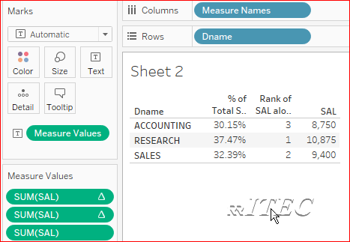

Organizing Fields using Folders
- By default columns are organized data source table wise.
- We can organize folder wise ,by creating business names
- Click on dimension → down arrow mark → select group by folder 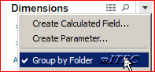
- Click on comm → Folders → Create Folder
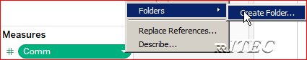
- Name it as Database Columns and drag drop sal column and observe it
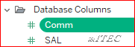

Parameters
- Parameters are dynamic values that can replace constant values in calculations, filters, and reference lines.
- For example, you may create a calculated field that returns true if Sales is greater than $500,000 and otherwise return false. You can replace the constant value of “500000” in the formula with a parameter. Then using the parameter control you can dynamically change the threshold in your calculation.
- Example 2: you may have a filter to show the top 10 products by profit. You can replace the fixed value “10” in the filter to by a dynamic parameter so you can quickly look at the top 15, 20, and 30 products.
- Calculate Top N employees
- Open Tableau → Click on connect to excel → navigate to RRITEC labdata folder → Select Scott Data excel file → drag and drop emp ,dept table
- Click on sheet1
- Click on dimension down arrow → click on Create Parameter
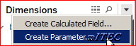
- Provide Name and values as shown below → click on ok
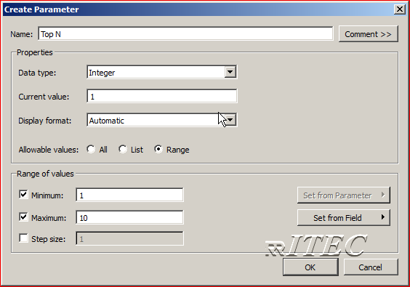
- Drag and drop Ename into rows shelf → sal into text
- Click on Ename → filter → provide as shown → click on ok
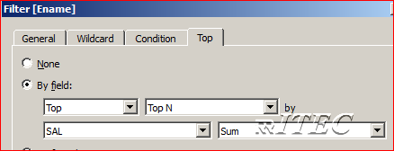
- Under parameters right click on Top N → click on show parameter control
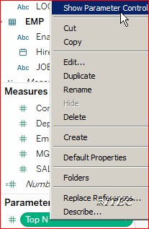
- Click on parameter card down arrow and select Type in
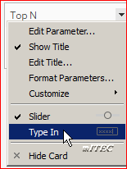
- Type 5 and observe it .similarly try with other numbers .
- Display Top N and Bottom N Customers by Sales
- Open Tableau → Click on connect to excel → navigate to RRITEC labdata folder → Select Sample - Superstore excel file → drag and drop orders ,People and Returns
- Click on sheet1
- Click on Down arrow of Dimension → click on create Parameter and provide below details
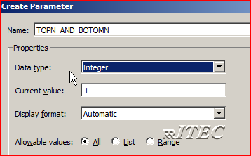
- Drag and Drop customer name into rows shelf → sales into text → sort sales in descending order
- Under measures →right click on sales → Create → calculation Field as shown
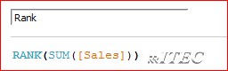
- Click on Down arrow of Dimension → click on create Calculation filed as shown
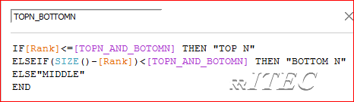
- Drag & drop TOPN_BOTTOMN into filter shelf→select TOP N and BOTTOM N
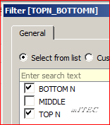
- Observe result
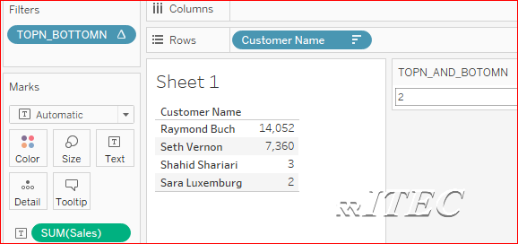

Conditional formatting
- Formatting data based on some condition .
- Open Tableau → Click on connect to excel → navigate to RRITEC labdata folder → Select Scott Data excel file → drag and drop emp ,dept table
- Click on sheet1
- Drag and drop empno,ename,job into rows shelf
- Drag and drop sal into text mark card
- Under measures → Right click on sal → Create → Calculation Field
- Name it as conditional formatting and develop below expression
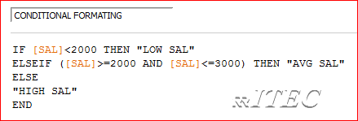
- Drag and drop conditional formatting column on to color marks card 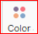
- Click on conditional formatting card → edit colors → select red /blue/green colors
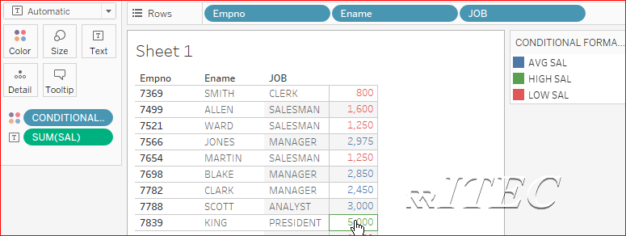

Highlighters
- In above report → go to analysis menu → highlighters → click on job column
- Observe by selecting different jobs
- Explore format options
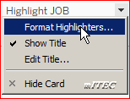

Types of Charts
- Show Me creates a view based on the fields already used in the view and any fields you’ve selected in the Data pane.
- Open Show Me by clicking Show Me on the toolbar .
- Build bar chart
- Open Tableau → Click on connect to excel → navigate to RRITEC labdata folder → Select Sample - Superstore excel file → drag and drop orders ,People and Returns
- Click on Sheet1
- Drag the Order Date dimension to Columns →Drag the Sales measure to Rows.
- On the Marks card, select Bar from the drop-down list →The view changes to a bar chart.
- Drag the Ship Mode dimension to Color on the Marks card.
  - The view shows how different shipping modes have contributed to total sales over time. The ratios look consistent from year to year.
- Drag the Region dimension to Rows, and drop it to the left of Sales to produce multiple axes for sales by region.
- To view data in the West region only, you can filter out the other regions. To do this, drag the Region dimension again, from the Data pane to the Filters shelf.
- In the Filter [Region] dialog box, clear the Central, East, and South check boxes, and then click OK.
  - This view gives you insight into your data—for example, how the ship mode changed in the West over the four-year period.
- One Step Further: Add Totals To Stacked Bars
- From the Analytics pane, drag a Reference Line into the view and drop it on Cell.
- In the Edit Line, Band, or Box dialog box, set the aggregation for SUM(Sales) to Sum, set Label to Value, and set Line under Formatting to None
- Then click OK to close the Edit Reference Line, Band, or Box dialog box.
- Your view now has currency totals at the top of each bar:
- Build Text Table : create a text table that shows sales totals by year and category
- Create text tables (also called cross-tabs or pivot tables) by placing one dimension on the Rows shelf and another dimension on the Columns shelf. You then complete the view by dragging one or more measures to Text on the Marks card.
- In above report → Click on New Sheet
- Drag the Order Date dimension to Columns
- Drag the Sub-Category dimension to Rows.
- Drag the Sales measure to Text on the Marks card.
- Select sum(sales) → click on sort sub category descending order by sales
- Drag the Region dimension to Rows and drop it to the right of Sub-Category.
- To create a table calculation to show percentages, right-click the SUM(Sales) field on the Marks card, and then select Add Table Calculation.
- In the Table Calculation dialog box, set Calculation Type to Percent of Total. The options in the dialog box change depending on the type of calculation you choose.
- For the Calculation definition, select Pane (Down), and then close the Table Calculation dialog box.
- Build Line Chart :
- Line charts connect individual data points in a view. They provide a simple way to visualize a sequence of values and are useful when you want to see trends over time, or to forecast future values
- In above report → Click on New Sheet
- Drag the Order Date dimension to Columns.
- Drag the Sales measure to Rows.
- Tableau aggregates Sales as SUM and displays a simple line chart.
- Drag the Profit measure to Rows and drop it to the right of the Sales measure.
- Tableau creates separate axes along the left margin for Sales and Profit.
- Drag the SUM(Profit) field from Rows to the Sales axis to create a blended axis.
- Click the drop-down arrow in the Year(Order Date) field on the Columns shelf and select Month in the lower part of the context menu to see a continuous range of values over the four-year period.
- Build Scatter Plot :
- In above report → Click on New Sheet
- Drag the Profit measure to Columns.
  - Tableau aggregates the measure as a sum and creates a horizontal axis.
- Drag the Sales measure to Rows.
  - Tableau aggregates the measure as a sum and creates a vertical axis.
  - Now you have a one-mark scatter plot:
- Drag the Category dimension to Color on the Marks card.
  - This separates the data into three marks—one for each dimension member—and encodes the marks using color.
- Drag the Region dimension to Detail on the Marks card.
  - Now there are many more marks in the view. The number of marks is equal to the number of distinct regions in the data source multiplied by the number of Category.
- To add trend lines, from the Analytics pane, drag the Trend Line model to the view, and then drop it on the model type Linear.
- Build Heat Map :
- Use heat maps to compare categorical data using color.
- In Tableau, you create a heat map by placing one or more dimensions on the Columns shelf and one or more dimensions on the Rows shelf. You then select Square as the mark type and place a measure of interest on the Color shelf.
- In above report → Click on New Sheet
- Drag the Segment dimension to Columns.
- Drag the Region and Sub-Category dimensions to Rows
- Drag the Profit measure to Color on the Marks card.
- Build Histogram :
- A histogram is a chart that displays the shape of a distribution. A histogram looks like a bar chart but groups values for a continuous measure into ranges, or bins.
- In above report → Click on New Sheet
- Drag Quantity to Columns.
- Click Show Me on the toolbar, then select the histogram chart type.
  - The histogram chart type is available in Show Me when the view contains a single measure and no dimensions.
- Three things happen after you click the histogram icon in Show Me:
  - The view changes to show vertical bars, with a continuous x-axis (1 – 14) and a continuous y-axis (0 – 5,000).
  - The Quantity measure you placed on the Columns shelf, which had been aggregated as SUM, is replaced by a continuous Quantity (bin) dimension. (The green color of the field on the Columns shelf indicates that the field is continuous.)
  - The Quantity measure moves to the Rows shelf and the aggregation changes from SUM to CNT (Count).
- Drag Segment to Color.
- Hold down the Ctrl key and drag the CNT(Quantity) field from the Rows shelf to Label.
  - Holding down the Ctrl key copies the field to the new location without removing it from the original location.
- Right-click (Control-click on a Mac) the CNT(Quantity) field on the Marks card and select Quick Table Calculation > Percent of Total.
- Build Gantt Chart :
- Use Gantt charts to show the duration of events or activities.
- In a Gantt chart, each separate mark (usually a bar) shows a duration. For example, you might use a Gantt chart to display average delivery time for a range of products.
- In above report → Click on New Sheet
- Drag the Order Date dimension to Columns.
  - Tableau aggregates the dates by year and creates column headers with labels for the years.
- On the Columns shelf, click the Year (Order Date) drop-down arrow, and then select Week Number.
  - The column headers change. Individual weeks are indicated by tick marks because there are 208 weeks in a four-year span—too many to show as labels in the view.
- Drag the Sub-Category and Ship Mode dimensions to the Rows shelf. Drop Ship Mode to the right of Sub-Category.
- Next, we'll size the marks according to the length of the interval between the order date and the ship date. To do this, create a calculated field to capture that interval
- In the toolbar menu, click Analysis > Create Calculated Field.
- In the calculation dialog box, name your calculated field OrderUntilShip.
- In the Formula box, enter the following formula and then click OK:
DATEDIFF('day',[Order Date],[Ship Date])
- The formula creates a custom measure that captures the difference between the Order Date and Ship Date values, in days.
- Drag the OrderUntilShip measure to Size on the Marks card.
- The default aggregation for OrderUntilShip is Sum, but in this case it makes more sense to average the values.
- Right-click the SUM(OrderUntilShip) field on the Marks card, and then select Measure (Sum) > Average.
- The view is coming along. But there are too many marks squeezed into the view.
- We can make our data more readable by filtering down to a smaller time window.
- Hold down the Ctrl Key and drag the Week(Order Date) field from the Columns shelf to the Filter shelf.
- In the Filter Field dialog box, select Range of Dates and then click Next.
- Set the range to a three-month time interval, such as 1/1/2013 to 3/31/2013, and then click OK.
- Drag the Ship Mode dimension to Color on the Marks card.
  - Now your view shows you all sorts of information about the lag between order times and ship times.
  - For example, you can see which ship modes are more prone to longer lag times, whether lag times vary by category, and whether lag times are consistent over time.
- Build Pie Chart :
- Use pie charts to show proportions.
- To create a pie chart view that shows how different product categories contribute to total sales
- In above report → Click on New Sheet
- Drag the Sales measure to Columns.
- Drag the Sub-Category dimension to Rows.
- Click Show Me on the toolbar, then select the pie chart type.
- To add labels, drag the Sub-Category dimension from the Data pane to Label on the Marks card.
- If you don't see labels, press (Ctrl + Shift + B )to make sure most of the individual labels are visible.
- Build Tree Maps:
- Use treemaps to display data in nested rectangles. You use dimensions to define the structure of the treemap, and measures to define the size or color of the individual rectangles.
- Treemaps are a relatively simple data visualization that can provide insight in a visually attractive format.
- To create a treemap that shows aggregated sales totals across a range of product categories, follow the steps below.
- In above report → Click on New Sheet
- Drag the Sub-Category dimension to Columns.
- Drag the Sales measure to Rows.
- Click Show Me on the toolbar, then select the treemap chart type.
  - In this treemap, both the size of the rectangles and their color are determined by the value of Sales—the greater the sum of sales for each category, the darker and larger its box.
- Drag the Ship Mode dimension to Color on the Marks card. In the resulting view, Ship Mode determines the color of the rectangles—and sorts them into four separate areas accordingly. Sales determines the size of the rectangles:
- Try another option to modify the treemap: click the Undo button to remove Ship Mode from view.
- Drag the Profit measure to Color on the Marks card. Now Profit determines the color of the rectangles, and Sales determines their size:
- Build Packed Bubble Chart :
- Use packed bubble charts to display data in a cluster of circles. Dimensions define the individual bubbles, and measures define the size and color of the individual circles.
- To create a basic packed bubble chart that shows sales and profit information for different product categories, follow these steps:
- In above report → Click on New Sheet
- Drag the Category dimension to Columns.
- Drag the Sales measure to Rows.
- Click Show Me on the toolbar, then select the packed bubbles chart type.
- Drag Region to Detail on the Marks card to include more bubbles in the view.
- Next we'll add another layer of information to the view.
- Drag Profit to Color on the Marks card:
- Drag Region to Label on the Marks card to clarify what each bubble represents.
- The size of the bubbles shows the sales for different combinations of region and category. The color of the bubbles shows the profit (the darker the green, the greater the profit).
- Build Map View :
- Use map views to display and analyze geographic data. To create map views, add geographic fields to the view, and then add measures or continuous dimensions to the Marks card.
- In above report → Click on New Sheet
- In the Data pane, double-click the City dimension.
- From Measures, drag Sales to Color on the Marks card. The marks in the view color according to the amount of sales in each city
- From Measures, drag Sales to Size on the Marks card. The marks in the view resize according to sales in each city.
- To adjust the size of the marks in the view, click Size on the Marks card, and then drag the slider to the right.
- To open the Map Layers pane, select Map > Map Layers. In the Map Layers pane, click the Style drop-down list, and then select Dark.

Dashboard
- A dashboard is a collection of several worksheets and supporting information shown in a single place so you can compare and monitor a variety of data simultaneously.
- For example, you may have a set of views that you review every day. Rather than flipping through each worksheet, you can create a dashboard that displays all the views at once.
- Similar to worksheets, dashboards are shown as tabs at the bottom of the workbook and update with the most recent data from the data source.
- When you create a dashboard, you can add views from any worksheet in the workbook. Each view you add to the dashboard is connected to its corresponding worksheet. That means when you modify the worksheet, the dashboard is updated and when you modify the view in the dashboard, the worksheet is updated.
- Dashboard Layouts are two types
  - Tiled
    - When a view or object is placed with this attribute, it becomes part of a single-layer grid that resizes based on the overall dashboard size. Tiled items don't overlap one another.
    - 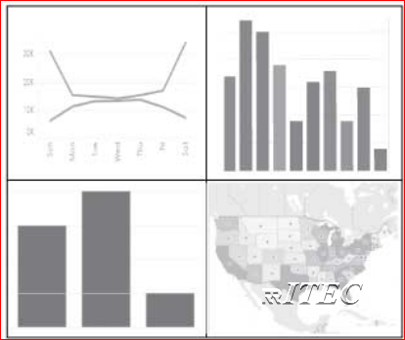
  - Floating
    - Items placed with this attribute can be layered on top of other objects. In the graphic below, every view is tiled except for the map view, which is floating.
    - 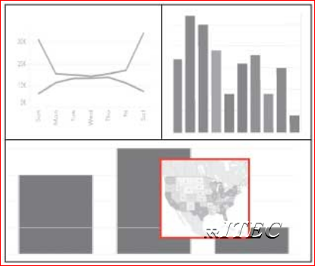
- Dashboard objects are 6 types
  - Horizontal
  - Vertical
  - Text
  - Image
  - Webpage
  - blank
- Build Basic Dashboard :
- Open Tableau → Click on connect to excel → navigate to RRITEC labdata folder → Select Sample - Superstore excel file → drag and drop orders ,People and Returns
- Click on Sheet1
- Develop below report and name it as year wise sales
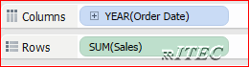
- Develop below report and name it as segment wise sales 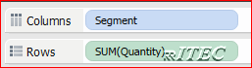
- Develop below report and name it as Detail
- 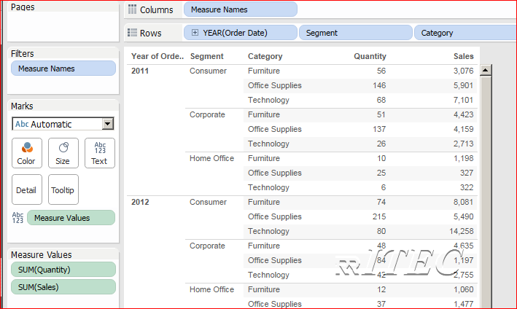
- Create a dashboard and name it as basic dashboard
- 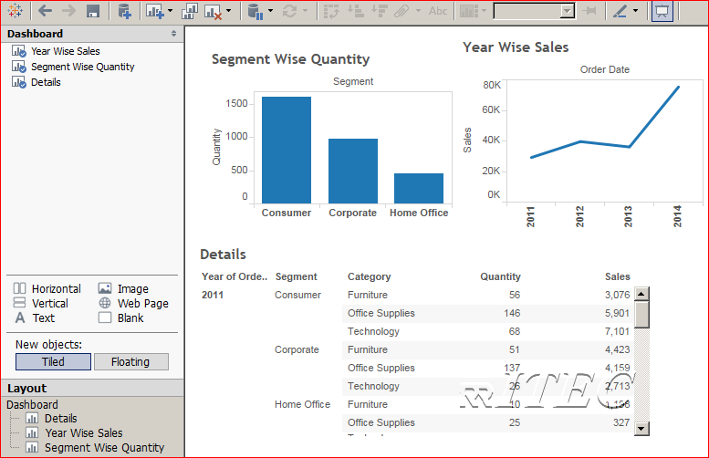
- Build one Master and two detail reports using Actions :
- Duplicate above dashboard → rename dashboard as one master and two details
- Go to dashboard menu → click on actions → Click on add action → filter
- Name it as filter on year → In source sheets select year wise sales → in target sheets select segment wise quantity and detail → Click on Select 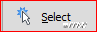 → Click on leave the filter → click on ok
- 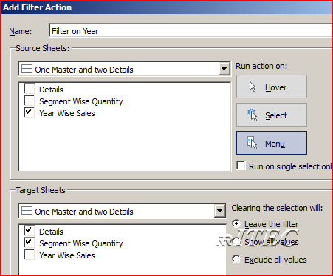
- Click on any year in year wise sales and observe other two reports.
- Build two Master and one detail reports using Actions :
- One master will not be impacted by other master.
- Duplicate above dashboard → Rename sheet as two masters and one detail
- Go to dashboard menu → click on actions → Click on add action → filter
- Name it as filter on segment → In source sheets select segment wise sales → in target sheets select detail → Click on Select → Click on leave the filter → click on ok
- Select filter on year 1 action → edit → uncheck segment wise quantity
- Select segment wise sales down arrow mark → select ignore actions
- Observe result.

- Navigating One dashboard page to other dashboard page using Actions :
- In above work book → go to basic dashboard → go to dashboard menu → click on actions → name it as 1 to other → select as shown → click on ok
- 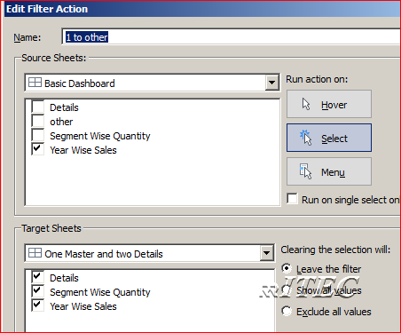
- observe result.
- Select sheets Dynamically
- Develop 3 sheets year wise sales, segment wise sales ,category wise sales
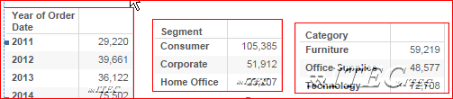
- Develop a dashboard with above three sheets
- Create a parameter with below options
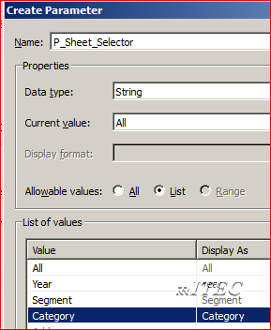
- Create a calculation field Cal_Selection → drag and drop above parameter.
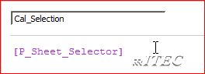
- Drag and drop above calculation into year wise sales sheet filter shelf → provide custom value list as shown below
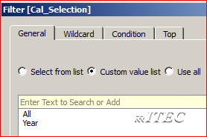
- Drag and drop above calculation into segment wise sales sheet filter shelf → provide custom value list as shown below
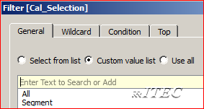
- Drag and drop above calculation into category wise sales sheet filter shelf → provide custom value list as shown below
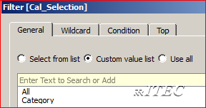
- Go to dashboard → Hide all three reports titles
- Show parameter in dashboard
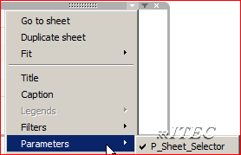
- Select different options in parameter and observe the result.
- To add dynamic titles create three calculations as shown
- 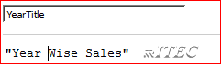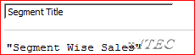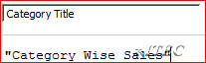
- Click on new sheet →drag and drop year title in rows and text and hide the headers.
- Similarly create two more sheets with segment title and category title
- Drag and drop these title sheets onto dashboard respective sheets using dashboard floating
- Go to year wise sales filter shelf → Click on apply to worksheets → Selected worksheets
- Select as shown
- 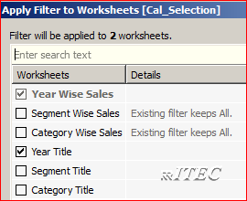
- Similarly do remaining two sheets filters.

Story
- A story is a sheet that contains a sequence of worksheets or dashboards that work together to convey information. You can create stories to show how facts are connected, provide context, demonstrate how decisions relate to outcomes
- A story is a sheet, so the methods you use to create, name, and otherwise manage worksheets and dashboards apply to stories.
- At the same time, a story is also a collection of sheets, arranged in a sequence.
- Each individual sheet in a story is called a story point.
- Tableau stories are not collections of static screen captures—your story points remain connected to the underlying data and change as the data changes—or as the views and dashboards that you use in your story change. When you share a story —for example, by publishing a workbook to Tableau Server or Tableau Online—users can interact with the story to reveal new findings or ask new questions of the data.
- The Story Workspace Has following controls, elements, and features
  - The Sheets pane
    - Drag dashboards and worksheets to your story.
    - Add a description to a story point.
    - Select to show or hide the navigator buttons.
    - Configure the story size.
    - Select to show the story title.
  - The story menu
    - Open the Format Story pane.
    - Copy the current story point as an image.
    - Export the current story point as an image.
    - Clear the entire story.
    - Show or hide the navigator buttons and the story title.
  - The navigator :
    - The navigator serves as a way to edit, organize, and annotate all the points in your story. You can also move through the story using the navigator buttons.
    - Click the forward arrow on the right of the navigator to move forward one story point , and the backward arrow on the left of the navigator to move back one story point. You can also use the slider that appears when you hover over the navigator to quickly scroll through all the points in the story, and then select one to view or edit.
  - Options for adding a new story point
    - Add a new blank point.
    - Save the current story point as a new point.
    - Duplicate the current story point.
- Once content has been added to a story, it only tracks changes as long as it has been unmodified on the story. Any changes made to content in a story do not reach back and update the underlying content whether it’s a dashboard or a sheet. Dashboards do reach back and update the sheet.
- Create sample story
- In above dashboard of selecting sheets → click on new Story
- Change title of story as " Learning Stories"
- Add description as tableau sample sales analysis
- Change caption of story point as category wise sales
- Drag and drop category wise sales sheet
- Click on new blank point → drag and drop segment wise sales
- Click on new blank point → drag and drop dashboard of above two sheets
- Observing impact of changes in sheet on dashboard/story
  - Develop a sheet with category,segment,sales and profit
  - 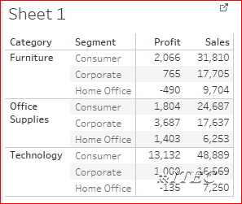
  - Right click on category → click on show filter
  - Right click on segment → click on show filter
- Case Studies
- KPMG’s Global Automotive Executive Survey

Creating Tableau Online Login and Tableau Site
- Go to URL https://www.tableau.com/products/cloud-bi → Click on TRY IT FOR FREE
- Fill the form sing your mail id and details
- 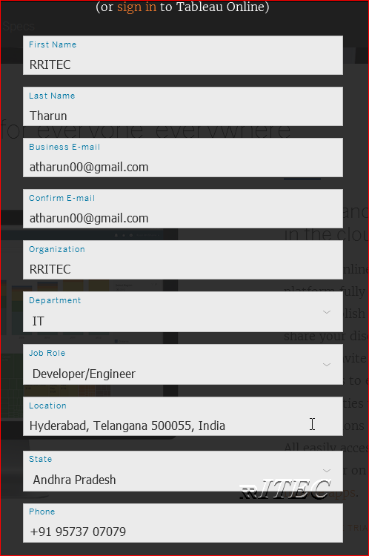
- Click on 
- We need wait few mins with below screen
- 
- Go to your mail and click on Activate My Site
- 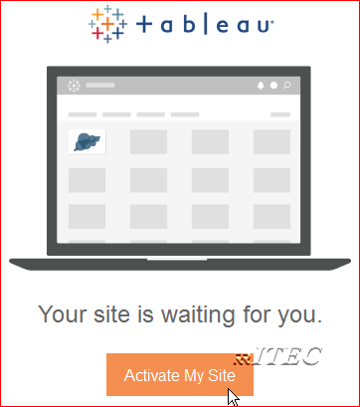
- Then go back to site creation page → provide below information → Click on activate my site
- 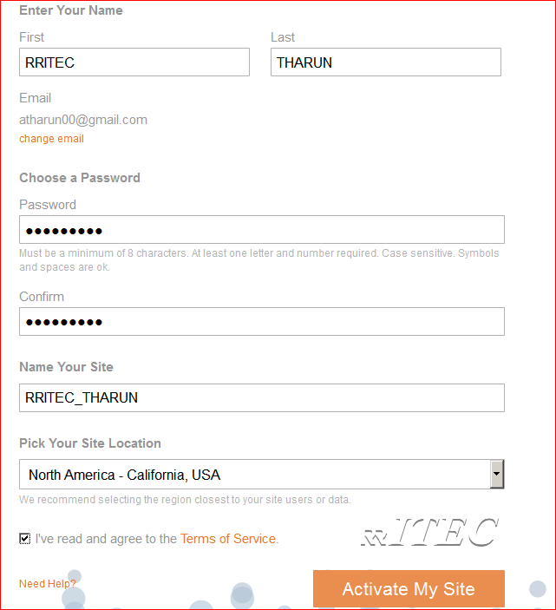
- Read all the information and Close the welcome screen
- 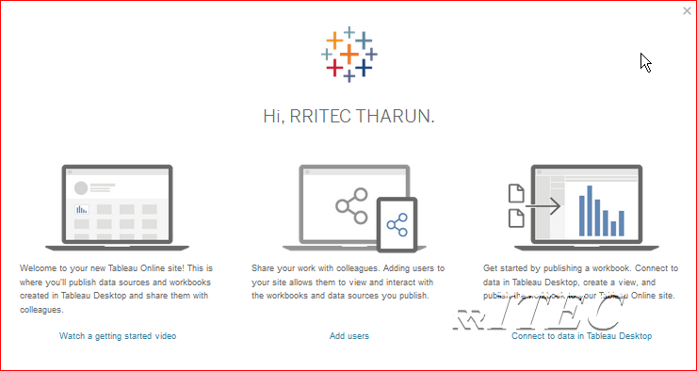
- Observe all the options like Content ,users,grops,schedules ,tasks, status and settings.

Create Project in online/cloud
- Project is a collection work books ,views(sheet) and datasources.
- Click on Content menu → Click on Projects → Click on
- Name it as RRITEC → Click on Create
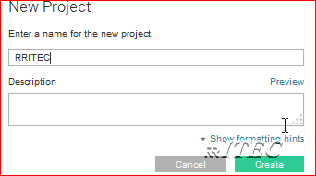
- Click on RRITEC project → Notice that as of now no Work books ,No views and No Data Sources

Publish Workbook to Online
- Go to Tableau desktop → Open any one work book
- Click on Server menu → click on sign in → provide online username and password
- Click on publish workbook
- Select all required options
- Go to online browser window observe workbook

Publish Datasource to online
- Go to Tableau desktop → Open any one work book
- Right click on datasource → Click on publish datasource
- Select all required options
- Go to online browser window observe datasource

Develop a work book using web datasource
- Click on content menu → Click on our project
- Click on data source → click on required data source
- Click on new work book
- Double click on any two columns (1 dimension and 1 measure)
- Create similarly one more sheet and dashboard
- Click on save as → provide name and save it

Installing Tableau Server
- Tableau supports only 32 and 64 bit windows operating systems
- CPU should have minimum 2 cores. to find number of cores go to run and type msinfo32.exe.
- Minimum 4 GB RAM
- Tableau all versions of software available in below site .
- Download software from https://www.tableau.com/support/esdalt
- Follow my blog for installation steps http://rritec.blogspot.in/2017/03/tableau-server-installation.html

Create Tableau Site in the server
- Site is the biggest object in the tableau.
- One Site is created for each organizations .
- In Tableau server we can host multiple sites .
- Go to URL http://localhost:8000
- Go to settings → Click on Add a Site tab→ Click on add site
- Provide site name as RRITEC → Click on Create
- Similarly create one more site with the name of Ram
  - Click on server → click on site → add site → name it as Ram → create

Create Tableau Project In the server in the site
- Click on Content menu → Click on Projects → Click on
- Name it as RRITEC → Click on Create
- Click on RRITEC project → Notice that as of now no Work books ,No views and No Data Sources.

Publish Workbook to server
- Go to Tableau desktop → Open any one work book
- Click on Server menu → click on sign in → provide username and password
- Click on publish workbook
- Select all required options
- Go to browser window observe workbook

Publish Datasource to server
- Go to Tableau desktop → Open any one work book
- Right click on datasource → Click on publish datasource
- Select all required options
- Go to browser window of server and observe datasource

Development directly in tableau server
- Open tableau server web page
- Open any one site
- Open any one project
- Click on Datasources tab
- Click on any one datasource
- Click on new work book
- Double click on any one dimension
- Double click on any one measure
- Similarly develop on e more sheet with other dimension and measure
- Click on dashboard
- Drag and drop above two sheets into dashboard
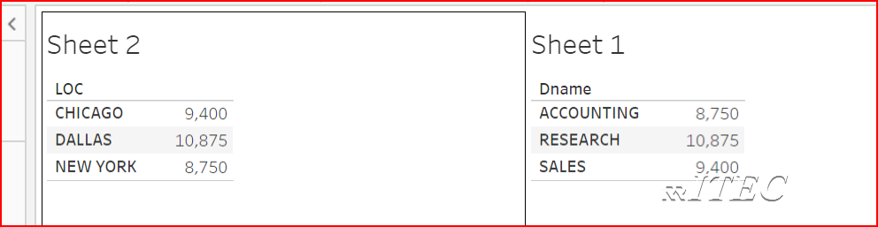
- Observe all options and compare with tableau desktop and try to know options not avalible in web page . For example
  - Can you create story directly in server?
  - Can you create parameters in server?
  - Can you create sets in server?
  - Can you create actions?
  - Do you have image dashboard object?
  - Do you have text dashboard object?
  - Similarly identify options not available in server.
- Go to file menu → save as → provide some name and observe it .
Can we change published workbook from desktop? yes
- Navigate to any one workbook in the server
- Open the work book
- Click on edit
- Add any one column
- Go to file menu click on save.

Create users
- In tableau we can create users in two ways
  - Create a new user account on Tableau Server
  - Import users from a CSV file
- Create a new user account on Tableau Server
  - Go to users page http://localhost/#/users
  - Click on
  - Click on new user
  - 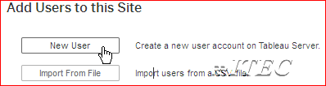
  - Provide below information and click on create
  - 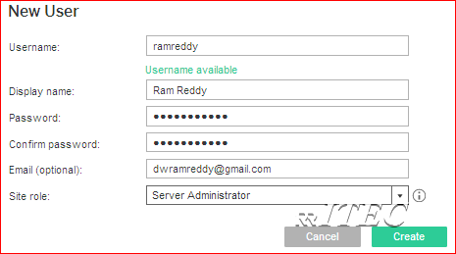
  - Logout and login using new user id and validate it .
- Create new users by importing csv file
  - The file does not include column headings. Tableau Server assumes that every line in the file represents a user.
  - The file is in UTF-8 format, and includes the byte-order mark (BOM).
  - Go to users page http://localhost/#/users
  - Click on
  - Click on Import From File
  - Go to labdata select users.csv file → Click on import users
  - 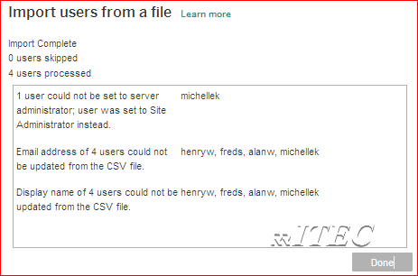
  - Click on done
Note: in above screen click on Learn More and read the help document line by line
- Go to desktop publish any work book using unlicensed (can Publish) user( in our case 07 rritec).
  - It will throw an error, please refer below known issue and modify register by visiting regedit (it is one time activity).
  - http://kb.tableau.com/articles/issue/error-your-account-is-not-licensed-signing-in-with-unlicensed-user-account
  - Once published login to webpage using admin user and observe our work book.
- Similarly do with all users one by one and observe it
- 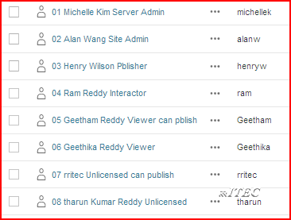

Create Group
- Set of users known as group
- Go to http://localhost/#/groups
- Click on new group
- Name it as RRITEC_GROUP → Click on Create
- 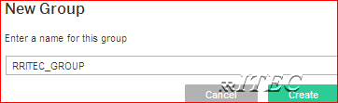

Map Users to group
- Click on group rritec_group → click on add users
- Select required users
- 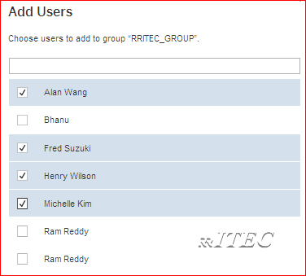
- Click on add users

About Roles and permission rules
- Site roles
  - Server Administrator
  - Site Administrator
  - Publisher
  - Interactor
  - Viewer
  - Unlicensed
  - Viewer(can publish)
  - Unlicensed(Can Publish)
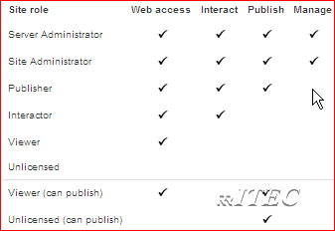
- Project templates
  - Viewer
  - Publisher
  - Project Leader
- Workbook templates
  - Viewer
  - Interactor
  - Editor
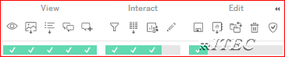
- Datasource template
  - Connector
  - Editor
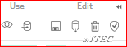
- Rules will not impact server/site administrator role
- Except admin role remaining all roles will be impacted by permission rules
- Provide interact permission rule on viewer site role → viewer is minimum permissions so it will execute
- Provide view permission rule on interact site role → viewer is minimum permissions so it will execute

Data Security
- When you share workbooks with others by publishing them to Tableau Server or Online, by default, all users who have access to the workbooks can see all of the data shown in the views. You can override this behavior by applying a type of filter that allows you to specify which data “rows” any given person signed in to the server can see in the view.
- Restricting access to data also known as row-level security (RLS). Tableau offers the following two approaches to row-level security:
- Create a user filter and map users to values manually.
  - This method is convenient but high maintenance, and security can be tentative. It must be done per-workbook, and you must update the filter and republish as your user base changes.
  - Open Tableau → Click on connect to text file→ navigate to RRITEC labdata folder → Select DataSecurity.csv file
  - Drag and drop DataSecurity file
  - Click on sheet1 → drag and drop columns as shown below
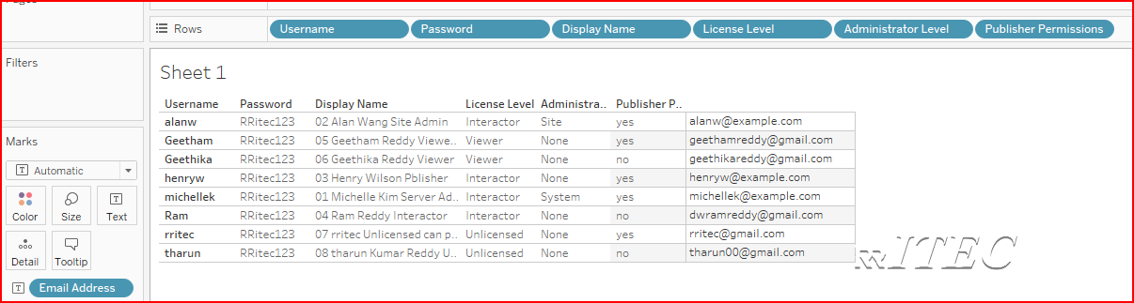
  - Click on server menu → create user filter → select username column
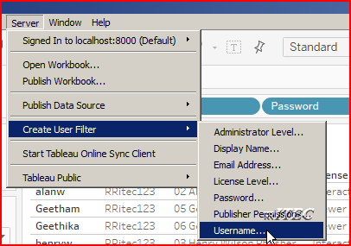
  - Map respective users to respective usernames
  - From sets pane drag and drop data security filter object into filter card
  - Publish the work book
  - Login with users and observe data
- Create a dynamic filter using a security field in the data.
  - Using this method, you create a calculated field that automates the process of mapping users to data values. This method requires that the underlying data include the security information you want to use for filtering.
  - Open Tableau → Click on connect to text file→ navigate to RRITEC labdata folder → Select DataSecurity.csv file
  - Drag and drop DataSecurity file
  - Click on sheet1 → drag and drop columns as shown below
  - Drag and drop username column into filter shelf
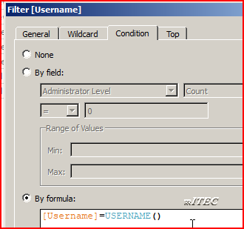
  - Publish the work book
  - Login with users and observe data

Scheduling and subscriptions
- Stop tableau server
  - Start → all programs → tableau server folder → stop tableau server
- Configure SMTP server
  - Start → all programs → tableau server folder → Configure tableau server
  - Click on SMTP page → provide below information as for your SMTP details (at present iam configuring gmail)
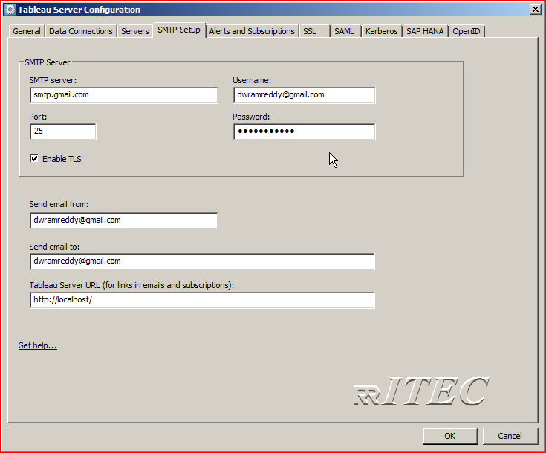
  - Click on Alerts and Subscriptions → Enable all the check boxes
  - Click on ok
  - Close the tableau configuration manager window
- Start he tableau server
  - Start → all programs → tableau server folder → start tableau server
- Enable subscription for site
  - Select site → settings
  - Select below options
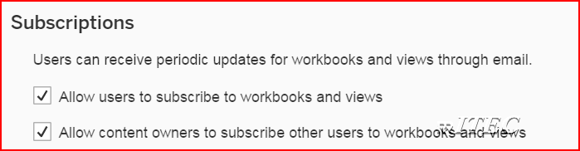
- Create schedule
  - Open server schedules page http://localhost/#/schedules
  - Click on new schedules → Name it as daily and provide below information → create
  - 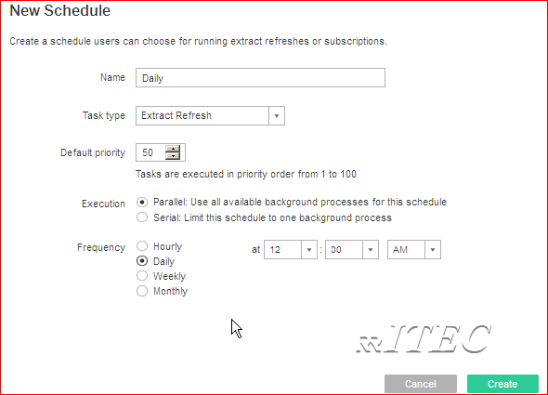
- Create Subscription
  - Open server schedules page http://localhost/#/schedules
  - Click on new schedules → Name it as Every_Day and provide below information → create
  - 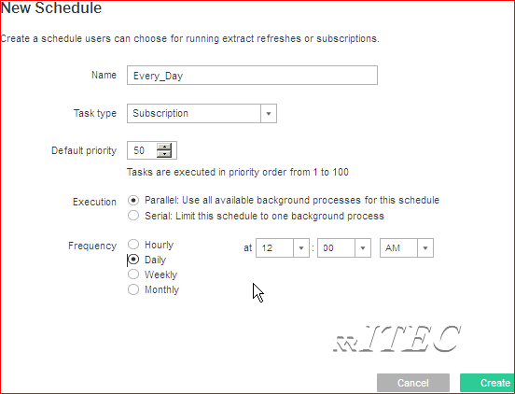
- Subscribe work book /View
  - Click on content → Open any project → open any work book → open any view
  - Click on Subscribe
  - Select all the options
  - 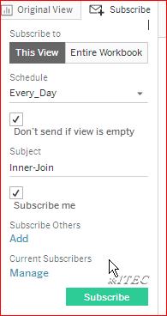
  - Click on subscribe.
- Refresh tableau data extract sing schedule
  - At the time of publishing TDE ,we can select required refresh schedule

Command Line Utilities

Tabcmd
- You can use the tabcmd command-line utility on a Windows computer to create scripts to automate administrative tasks on your Tableau Server site. For example, creating or deleting users, projects, and groups.
- The utility is installed automatically when you install Tableau Server
- Open cmd → change directory to C:\Program Files\Tableau\Tableau Server\10.2\bin
- Login to server
  - tabcmd login -s http://localhost/ -u dwramreddy -p RRitec123
- Create new site
  - tabcmd createsite "RRITEC_SITE"
- Login to new site
  - tabcmd login -s http://localhost:8000/ -t RRITEC_SITE -u ram -p RRitec123
- Create new project
  - tabcmd createproject –n “RRITEC_PROJECT” –d “Learn Tabcmd commands”
- Creating users
  - tabcmd createsiteusers C:\Users\RAMREDDY\Desktop\users.csv
- Creating group
  - tabcmd creategroup rritec_group
- Add users too group
  - Create a csv file with username and password on the desktop
  - tabcmd addusers rritec_group --users C:\Users\RAMREDDY\Desktop\users.csv
- Delete workbook
  - tabcmd delete --project rritec_project --workbook "RRITEC_WORKBOOK"
- Delete datasource
  - tabcmd delete --project rritec_project --datasource "RRITEC_DATASOURCE"
- List domains
  - tabcmd listdomains
- List Sites
  - tabcmd listsites
- List Version
  - tabcmd version
- Logout from server
  - tabcmd logout
- For more commands refer https://onlinehelp.tableau.com/current/server/en-us/tabcmd_cmd.htm
- Create batch file using above commands. For example
  - Open notepad
  - Type as shown below
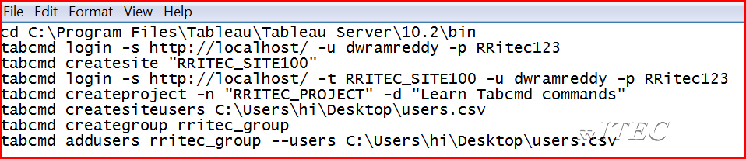
  - Save as cmd file
  - Double click on cmd file and observe all activities

- Using windows scheduler ,schedule above batch file
  - Create a batch file you wish to run and place it under a folder where you have enough permissions. For example under C drive.
  - Click on Start and under search, type in Task and click open Task Scheduler
  - Select Create Basic Task from the Action pane on the right of the window
  - Under Create Basic Task, type in the name you like and click Next
  - From the Trigger(ex one time) select the option you like and click Next
  - Then click on Start a Program and click Next
  - Now click on Browser and select the batch file you like to run
  - Finally, click on Finish to create the Task.

Tabadmin
- You can perform certain administrative tasks and change Tableau Server configuration settings using the Tabadmin command line tool. It installs with Tableau Server by default and cannot be installed on other computers.
- The utility is installed automatically when you install Tableau Server
- open a command prompt as an administrator
- Change directory to C:\Program Files\Tableau\Tableau Server\10.2\bin
- Observe all supporting commands using help command
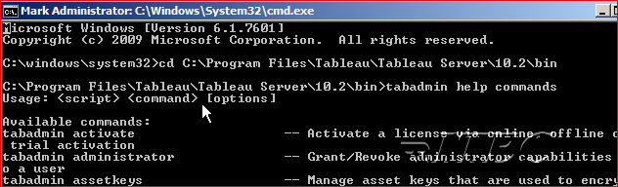
- Observe the status of server
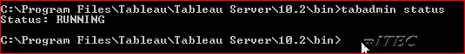
- Observer validate and licenses commands
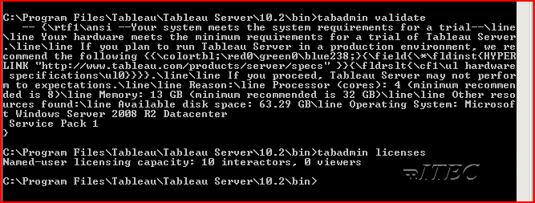
- For more commands refer https://onlinehelp.tableau.com/current/server/en-us/tabadmin_cmd.htm

Revision History
- When revision history is enabled on your site and you publish a workbook or data source, Tableau Server saves a version of it in its revision history. If you want to revert to a previous version, you can go to the content in Tableau Server and restore that version.
- To enable revision history → go to site settings → Enable revision history
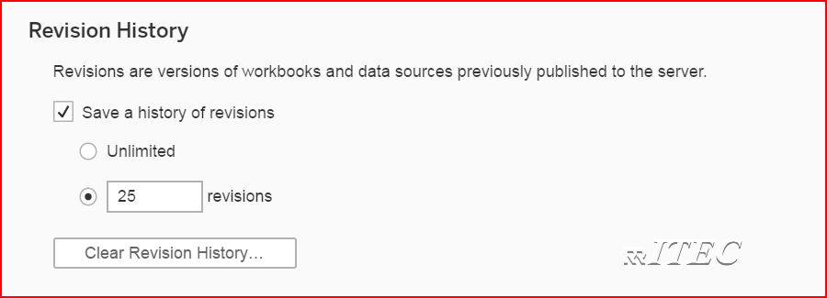
- On Tableau Server, your administrator can enable revision history for both workbooks and data sources. On Tableau Online, revision history is always enabled, but for workbooks only.
- To access revision history, you must have a site role of Publisher
- In Tableau Desktop, click Server > Publish Workbook or Server > Publish Data Source. Make changes to the same workbook or data source, and then publish it again to the same project, with the same name. (You'll need to confirm that you want to overwrite the existing content.)
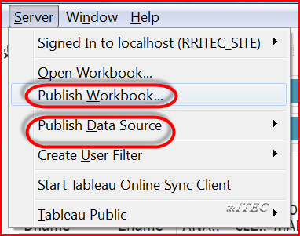
- You can also save workbook revisions by editing and saving a workbook in the web-authoring interface of Tableau Server.
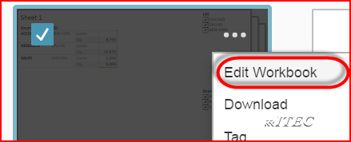
- Select a workbook or data source, and from its actions menu (. . .), select Revision History.The following image shows a workbook's revision history.
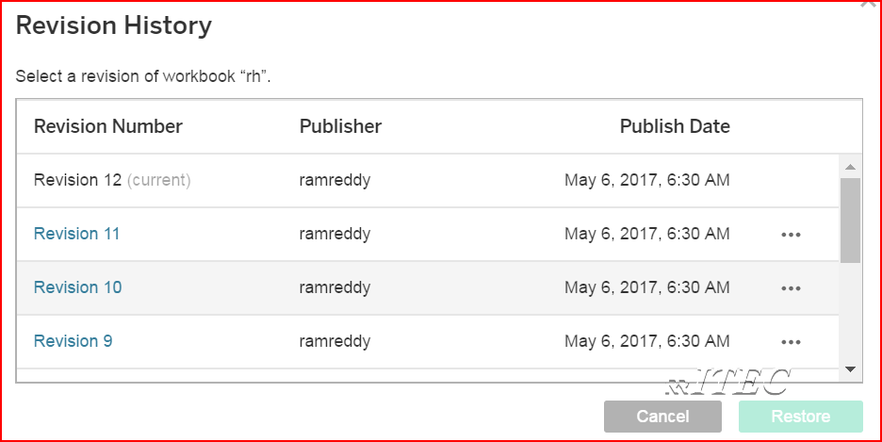
- We can preview ,delete, download or restore the versions
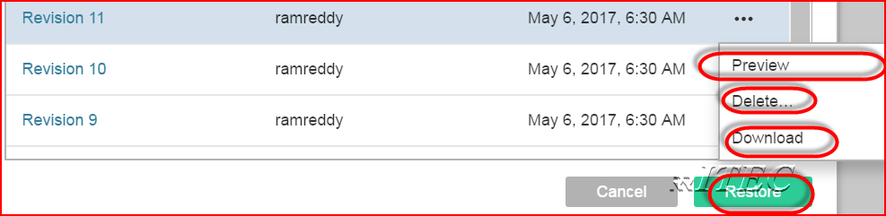
- If a revision can't be restored directly on the server, download the revision, open it in Tableau Desktop, and republish it.(it may happens in case of datasource)

List of Tableau Processes
- To observe all services of tableau open tableau server configuration → go to servers tab
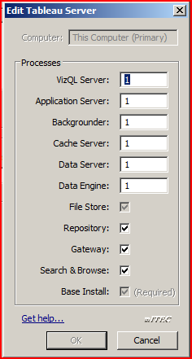
- Using Tabadmin command also we can see status
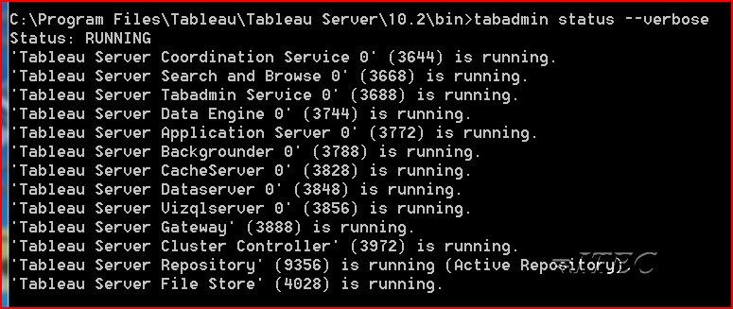
- All these service .exe files available in location C:\Program Files\Tableau\Tableau Server\10.2\bin
- We have around 10 services ,those are
  - VizQL Server
  - Application Server
  - Backgrounder
  - Cache Server
  - Data Server
  - Data Engine
  - File Store
  - Repository
  - Gateway
  - Search &Browse
- VizQL Server
  - Loads and renders views, computes and executes queries
  - The exe file of the server is vizqlserver.exe
- Application Server
  - Useful to Handles the web application
  - The exe file of the server is vizportal.exe
- Backgrounder
  - Useful to Executes server tasks, including extract refreshes, subscriptions, ‘Run Now’ tasks, and tasks initiated from tabcmd
  - The exe file of the services is backgrounder.exe
- Cache Server
  - Useful to cache queries
  - The exe file of the server is redis-server.exe
- Data Server
  - Manages connections to Tableau Server data sources
  - The exe file of the server is dataserver.exe
- Data Engine
  - Stores data extracts and answers queries
  - The exe file of the server is tdeserver64.exe
- File Store
  - Automatically replicates extracts across data engine nodes
  - The exe file of the server is filestore.exe
- Repository Store
  - Tableau Server database, stores workbook and user metadata
  - The exe file of the server is postgres.exe
- Gateway
  - The Tableau Server gateway process is an Apache web server component (httpd.exe). Its role is to handle requests to the server from all clients—Tableau Desktop, mobile devices, a proxy, a load balancer, etc.
  - The exe file of the server is httpd.exe
- Search & Browse
  - Handles fast search, filter, retrieval , and display of content metadata on the server
  - The exe file of the server is searchserver.exe

Working with Log Files
- https://onlinehelp.tableau.com/current/server/en-us/logs_working_with.htm

Viewing Underlying SQL Queries
- http://kb.tableau.com/articles/howto/viewing-underlying-sql-queries-desktop

Performance tuning
- Record performance tuning for any sample dashboard and understand it
  - Open desktop → go to help → sample workbooks → open superstore dashboard
  - Again go to help → settings and performance → Start performance recording
  - Navigate among different pages of dashboard and change filters
  - Again go to help → settings and performance → Stop performance recording
  - Understand the performance tuning dashboard
- Environmental
  - The client machine
    - 64 bit OS is faster than a 32 bit OS.
    - More memory is better.
    - Faster disk, backplane, memory etc. is better.
  - Network bandwidth
    - When large results sets are being returned to a client , from a server, more bandwidth is better.
  - The Tableau Server
    - More memory is, usually, better.
    - Faster disks are, usually, better.
    - More/faster CPUs can be better.
  - The browser
    - A recent test, two side by side machines running the same pull from the Tableau server.
    - IE7 returned results in 11 seconds
    - Firefox returned results in 3 seconds
- Database
  - Application tuning
    - If running a relational database, a finely tuned database instance and application will yield better performance results.
  - INDEXES
    - Make certain you have indexes on all columns that are part of table JOINs.
    - Make certain you have indexes on any column used, within Tableau, in a FILTER.
    - EXPLICITLY define PRIMARY KEYs, on all tables, if possible.
    - EXPLICITLY define all FOREIGN KEY relationships. This enables Tableau to bypass many of its integrity checks, since it knows the database is doing that verification
    - Many DMBS environments have management tools that will look at a query, and, recommend indexes that would help.
  - For Large Data
    - consider table partitioning. In most situations, no query result is meaningful unless constrained by time. Consider partitioning at the date/time level if this is your situation.
  - NULLS
    - Programmers and Tableau Desktop do not like NULL data . Define each column in your tables with an explicit “NOT NULL.”, if possible.
  - Calculations
    - If complex calculations are needed, in Tableau, consider creating a DBMS VIEW that does the calculation – the database server is usually more powerful than the desktop!
  - Summary Tables
    - Consider the use of pre computer aggregate (summary) tables when large dataset are, typically, summarized when used. Note – you can use Tableau Desktop to automatically create summarized tables. See Extracts.
  - Technique
    - Turn off automatic updates
      - On the tool bar you will see a button with a Green Arrow on it. When you hover over it, the tool tip will say “Pause Automatic Queries”. With very large databases, I recommend clicking it until you’ve added a few measures and dimensions to your analysis. Then, click on it again and it will “Resume Automatic Queries” but now the selection will be more specific. If automatic updates are on, feel free to select the skip button to progress the dialog.
    - Data Sources
      - When creating data sources, use the Multiple Tables options whenever possible and avoid using Custom SQL. Tableau will be able to optimize its queries when using Multiple Tables. A Custom SQL data source works fantastic when needed, but will use sub queries as follows:
Select sum([Sales]), customer from <insert custom sql here> Group by customer Order by sum[(Sales)] desc Where Region] = West
      - Use as few data sources as needed to achieve your analysis.
      - Remove any unused data sources.
      - When adding a table to a data source with joins, select the ‘tables’ option from the data. Tableau will skip several validation steps in this case.
    - Add a context filter for relevant data
      - This can be faster than an extract. This is because we still leverage the speed, power and optimization of the database instead of relying on the client machine. Plus, there is no need to re-extract to get current data. The context filter handles that automatically when the workbook is opened. Context filters will work best for you if you are filtering more than 90% of your data as a rule of thumb. Also, Context Filters work best on dimensions that either slowing change or do not change at all.
    - Extracts
      - Tableau can create extremely fast extracts using its architecture aware extract engine. When creating extracts there are a few techniques that can you can employ to make the most out of them.
      - Make sure that you hide any unnecessary fields from
      - your data window. Tableau will only extract the fields that are unhidden. By hiding these fields, you will reduce the size of your extract from a columnar perspective.
    - If your data is at a smaller grain than needed for your analysis or content requires, Tableau can create an extract that is aggregated to the level of detail that is needed. This can be done with a few clicks by going to the Data>Extract data... menu item then selecting the Aggregate data for visible dimensions and pressing the Hide All
    - Unused fields button. Now your data will be as small as it can possibly be while keeping the necessary level of detail.
    - You can also extract a subset of data – either a filtered subset (say one month of data) or a random sample of data.

    - This will give you the opportunity to create your analytical content and when you are ready to bring the power of Tableau to bear on the complete data set, deselect the Use Extract menu item.
  - When using Filters
    - When filtering, try to avoid the “Exclude” option. When the Exclude option is used Tableau must scan all the selected data – there is no opportunity for Tableau to use any INDEX! When filtering time dimensions, avoid using the “Individual dates and times” filter type. This filter type will explicitly query for each date and time available. If needed, use cascading quick filters for Years, Months and Days to show only the data that you are looking for. Also, the relative date filter is an easy way to show the current week or month of data without having to edit your workbook or republish to Tableau Server. Relevant value quick filters can create expensive queries, only use when needed.
  - Content
    - When authoring content in Tableau Desktop, there are many different ways to achieve the same analysis. Some of the ways perform better than other methods. This section will explore some of the choices that can be made when creating calculations will a focus on the better performing options.
    - Use Boolean calculations whenever possible A standard IF THEN statement that returns only two values would look like this:
IF [Date]= TODAY() then “Today” ELSE “Not Today” END
A faster performing calculation would be:
[Date]=Today()
Then use Aliases to rename the TRUE and FALSE results to “Today” and “Not Today”.
    - Use ELSEIF rather than ELSE IF in your logical statements. The nested IF computes a second IF statement, rather than being computed as part of the first one.
      - Below code:
IF [Region] = "East" and [Customer Segment] = "consumer" then "East-Consumer" Else IF [Region] = "East" and Customer Segment] <>"consumer" then "East-All Others" end end
      - Would run much faster as:
IF [Region] = "East" and [Customer Segment] = "consumer" then "East-Consumer" Elseif [Region] = "East" and [Customer Segment] <>"consumer" then "East-All Others" end
    - Using Date Functions
      - Use NOW() only if you need the time stamp level of detail . Use Today() for date level calculations.
      - Tableau only queries a row of data once in a calculation
      - Calculations such as the one below seem complete, but contain redundant calculations:
IF [Sales] < 10 Then "Bad" Elseif [Sales]>= 10 and [Sales] < 30 Then "OK" Elseif [Sales] >= 30 then "Great" end
Instead take advantage of the logic that has already been performed:
IF [Sales] < 10 Then "Bad" Elseif [Sales] >= 30 then "Great" else "OK" end
    - When using extracts and custom aggregations, divide the calculation into multiple parts. Place the row level calculations on one calculated field, and the aggregated calculation in a second calculated field. Then extracts can optimize (pre compute) the row level calculations.

Deployment
- https://community.tableau.com/blogs/toby/2015/04/13/exportingimporting-a-site--part-1

- 
 